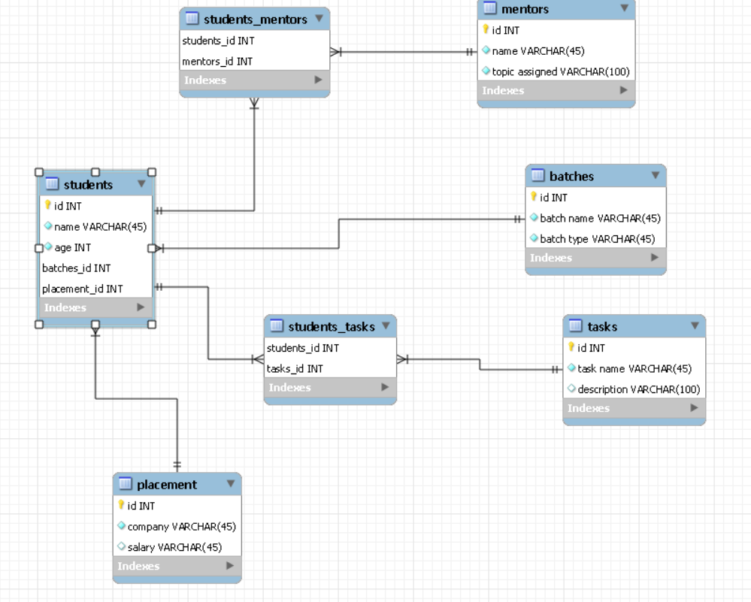

1. **Students --- mentors (many-many)**
2. **Students --- batches (many-one)**
3. **Students --- tasks (many-many)**
4. **Students --- placement (many-one)**